**Chapter 2:**

**2. project planning:**

The most crucial and fundamental phase of the project management life cycle is project planning. By establishing the project's scope, timeline, quality standards, objectives, and goals, the project planning activity lays the groundwork for the entire project. Creating a document containing all project details, including tasks, assignees.

**2.1. Schedule Plan:**

The precise arrangement of project tasks and activities according to time constraints is known as a schedule management plan. It lists the beginning and ending dates of all the tasks and milestones that need to be reached in order to finish the project. A crucial step in project planning is creating a schedule management plan, which will guarantee that your projects are started, tracked, managed, and finished successfully (Udoagwu, 2023).

**Table 2.1**

*Schedule Plan*

|  |  |  |  |  |
| --- | --- | --- | --- | --- |
| **Task name** | **Duration** | **Start of Task** | **Finish of Task** | **Responsible person** |
|  |  | **Chapter 1** |  |  |
| 1.1 Overview of Project case Business case | 2 days | 30/3/24 | 1/4/24 | Tasneem |
| 1.2 Preliminary Investigation | 3 days | 30/3/24 | 2/4/24 | Noor |
| 1.3 Project Scope | 2 days | 30/3/24 | 1/4/24 | Maryam |
| 1.4 Feasibility Study | 2 days | 30/3/24 | 1/4/24 | Zuhad |
|  |  | **Chapter 2** |  |  |
| 2. Project plan | 1 day | 15/4/24 | 15/4/24 |  |
| 2.1 Schedule plan | 1 day | 15/4/24 | 15/4/24 |  |
| 2.1.1 Work Breakdown Structure | 2 day | 15/4/24 | 16/4/24 |  |
| 2.1.2 Gantt Chart | 4 days | 16/4/24 | 19/4/24 |  |
| 2.2 Risk plan | 1 day | 16/4/24 | 16/4/24 |  |
| 2.3 Team communication plan | 2 days | 17/4/24 | 18/4/24 |  |
|  |  | **Chapter 3** |  |  |
| 3. Requirements Gathering & Analysis | 1 day | 21/4/24 | 21/4/24 |  |
| 3.1 Methodology Used (SDLC model) | 2 days | 21/4/24 | 22/4/24 |  |
| 3.2 Tools of Data Gathering | 4 days | 22/4/24 | 26/4/24 |  |
| 3.3 Data Analysis | 2 days | 22/4/24 | 23/4/24 |  |
| 3.4 Data Modeling / Process modeling | 1 day | 23/424 | 23/4/24 |  |
| 3.5 Technical Requirements | 2 days | 23/4/24 | 24/4/24 |  |
| 3.6 Literature Review | 3 days | 23/4/24 | 25/4/24 |  |
|  |  | **Chapter 4** |  |  |
| 4.1 Design Details | 1 day | 28/4/24 | 28/4/24 |  |
| 4.2 Flow Chart | 3 days | 28/4/24 | 30/4/24 |  |
| 4.3 Context Diagram | 4 days | 29/4/24 | 1/5/24 |  |
| 4.4 Data Flow Diagram | 3 days | 29/4/24 | 30/4/24 |  |
| 4.5 Case / Use case diagram | 2 days | 29/4/24 | 30/4/24 |  |
|  |  | **Chapter 5** |  |  |
| 5.1 Screen Shots | 2 days | 5/5/24 | 6/5/24 |  |
| 5.2 Testing / Evaluation | 3 days | 5/5/24 | 7/5/24 |  |
|  |  | **Chapter 6** |  |  |
| 6.1 Deployment | 1 day | 15/5/24 | 15/5/24 |  |
| 6.2 Conclusion | 1 day | 15/5/24 | 15/5/24 |  |
| 6.3 Individual Reflection | 1 day | 15/5/24 | 15/5/24 |  |

**2.2. Work Breakdown Structure**

A work breakdown structure (WBS) is a project management system that breaks down projects into manageable tasks, assigning each task a unique identifier and placing them within a hierarchical structure. Its main goals are to provide a clear project scope, identify necessary work, and enhance effective planning and management.

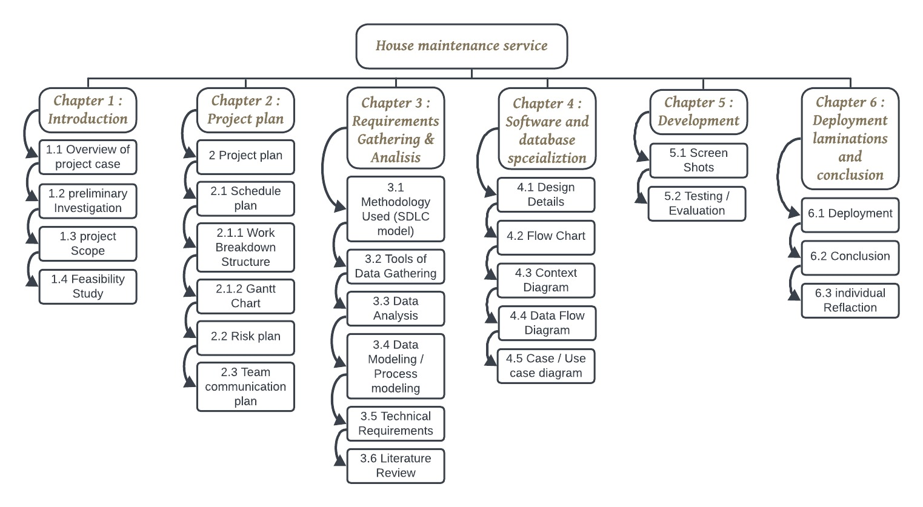

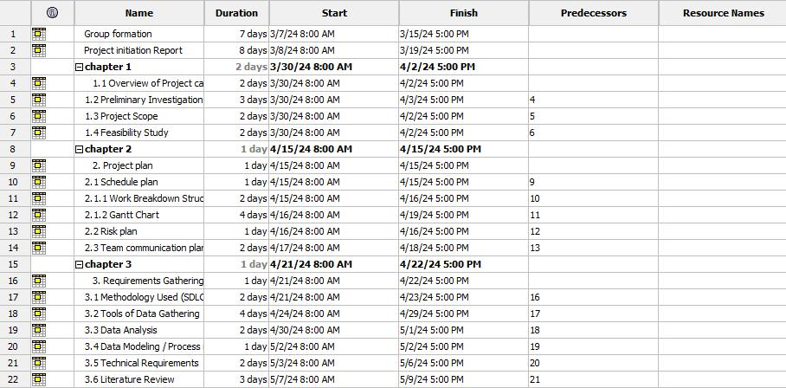

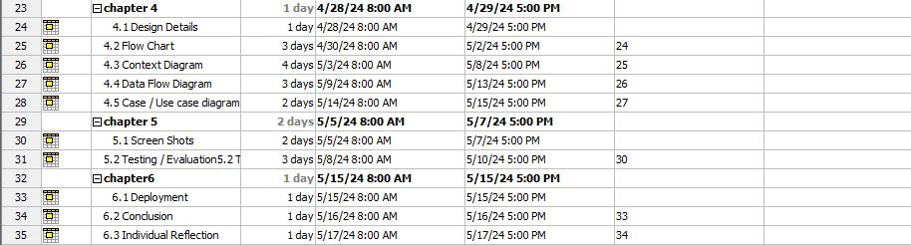

**Gantt Chart:**

Gantt charts are a useful tool for project management that can be used to schedule and plan tasks of any size. They are particularly useful for project visualization. Project managers can use a Gantt chart, which plots an activity's graphic representation against time, to monitor their progress.In situations where a large team and numerous stakeholders are involved, a timeline, similar to a Gantt chart, helps keep projects on schedule. They are an effective tool for tracking progress and managing time. Both the total expected time and the individual tasks should be displayed on a Gantt chart. It ought to consider each proposal that is a component of your project and divide it into doable chunks, like calculating.

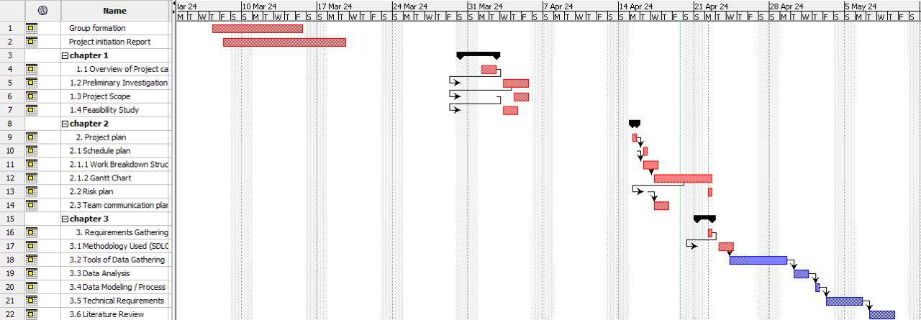

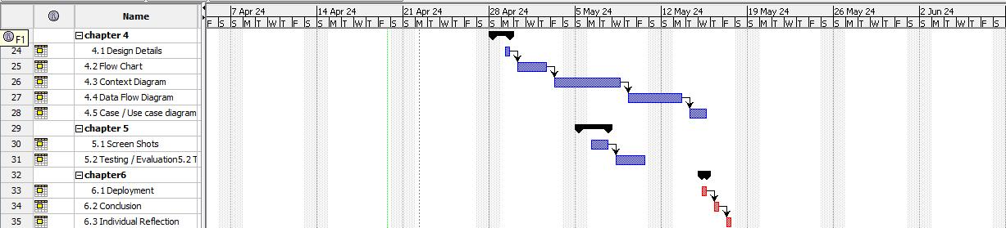

**2.2 Risk plan:**

|  |  |  |  |
| --- | --- | --- | --- |
| **Risk** | **Probability of occurrence** | **Impact** | **Mitigation/Management plan** |
| Insufficient planning | Medium | high | detailed and accurate planning, management Strong the team and Participation. |
| Weak technologies | Low | Medium | Using effective techniques or tools that contribute to the progress and development of the project. |
| Environmental changes | Medium | High | Work and participate online or gather in a suitable place. |
| Scheduling risks | high | high | Commitment to the deadline, cooperating with the team. |
| Technical problems | Medium | high | Multi-networking, data preservation. |

A risk management plan is a written document that directs a team's risk management activities. It outlines the possible risks associated with a project, the ways to mitigate those risks, the resources required, and the rules for reporting that must be adhered to. You can use our free Word risk management plan template for any of your projects.

**2.3 Team communication plan:**

|  |  |  |  |  |
| --- | --- | --- | --- | --- |
| DAY | PLACE | TIME | TYPE OF MEETING | NOTES |
| Sunday | Class | 12:50am | Face to face | Discuss to gather to complete the work |
| Wednesday | Whats app | 8:07 PM | Online | Complete and solve the chapter |
| Tuesday | Whats app | 8:12PM | Online | discussing and distributing tasks for each member of the team and exchanging views and ideas |
| Daily | Whats app and some time in college | No specific time | Online – face to face | Discussing details about project. |

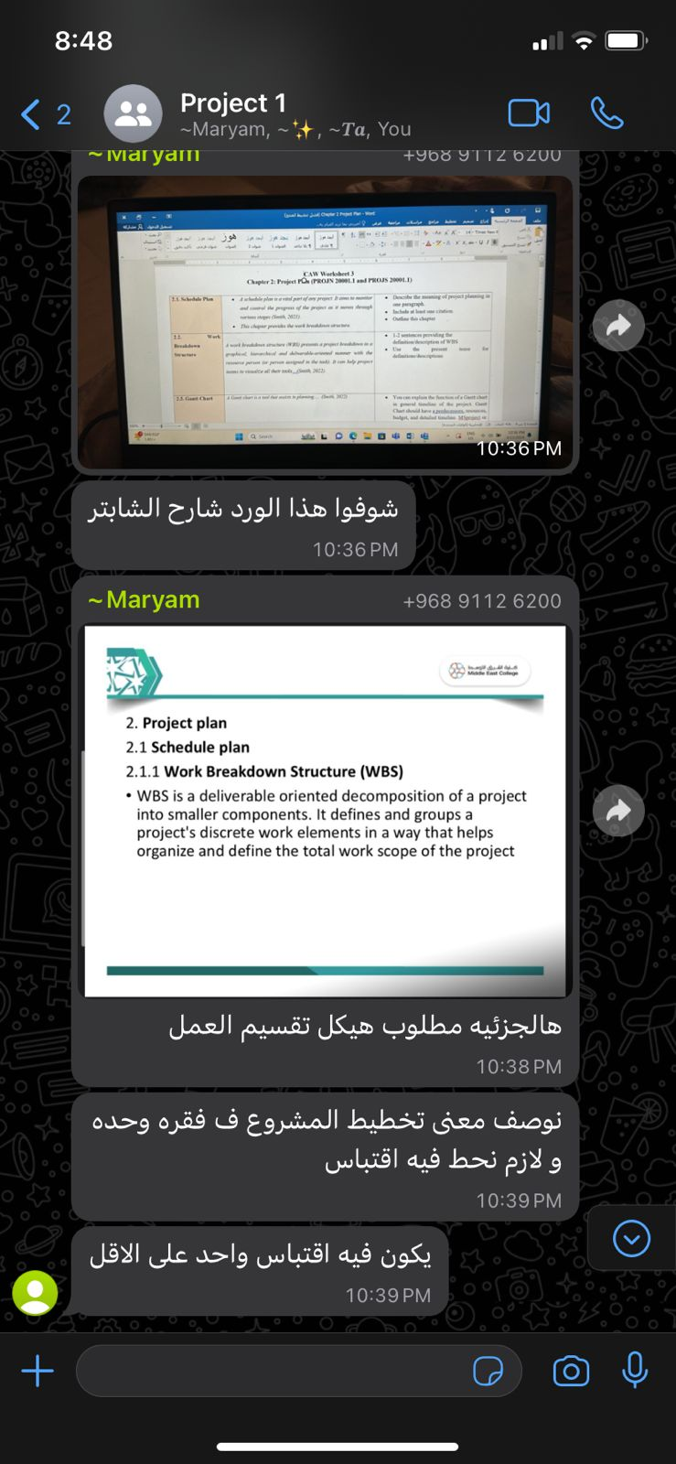 **Evidence:**



